SESSION — ACTIVITY (20 MIN) • STUDENT HANDOUT • SLOT D

Redesign the Misleading Colored Chart
R.No: 25 Reg. No: 192424373 Name: MINNAL VENKTESAN RAGHAVAN
Each chart below uses color in a misleading or confusing way. For each one, answer the three questions in your own words.
Chart 1
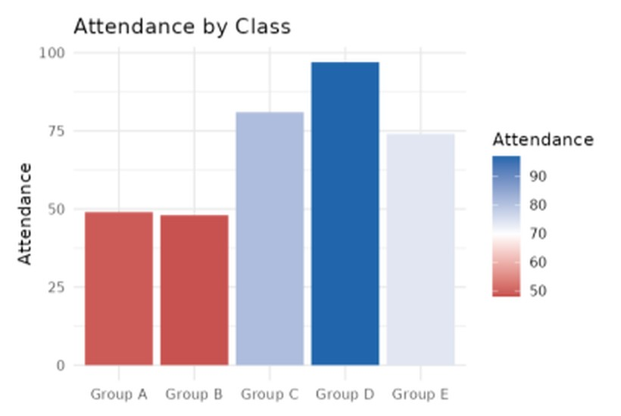
1.What is this chart trying to show?
The chart shows the attendance for each class group (Group A to Group E). The height of each bar represents the attendance value for that group, out of 100.
2.What's wrong with the color choice?
The chart uses a red-to-blue color gradient, so the colors make a judgement (red looks "bad" and blue looks "good") that the data itself does not state. The color just repeats the bar height, so it adds no new information, and the white midpoint (around 70) is an arbitrary cut-off. The very pale bar for Group E (74) almost blends into the white background, which makes it look smaller or less important than it really is. The extra color legend also makes the viewer work harder to compare the values.
3.Propose a better color scheme (describe it in words):
Use one single color, such as medium blue, for all five bars, since they all measure the same thing. If a group needs to be highlighted (for example, the groups with attendance below 75), show only those bars in a darker blue or one accent color and keep the rest in a light grey-blue.
Remove the color legend and add value labels on the bars instead.
SESSION — ACTIVITY (20 MIN) • STUDENT HANDOUT • SLOT D

Redesign the Misleading Colored Chart
Chart 2
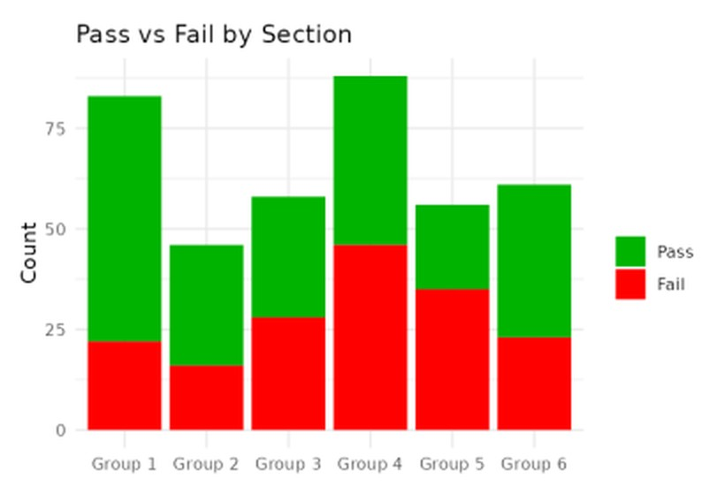
1.What is this chart trying to show?
The chart shows the number of students who passed and failed in each section (Group 1 to Group 6). Each stacked bar shows the total count, split into the Pass part and the Fail part.
2.What's wrong with the color choice?
Pure red and pure green are the classic problem pair, because people with red-green color blindness (about 1 in 12 men) cannot tell them apart. The colors are also extremely bright and saturated, so they strain the eyes, and the strong red grabs more attention than the green and makes Fail look more important. In addition, the colors carry a "good/bad" meaning that is not needed to read the chart.
3.Propose a better color scheme (describe it in words):
Use a color-blind-friendly pair such as blue for Pass and orange for Fail, in slightly muted tones so neither dominates. Another option is a dark blue for Pass and a light grey for Fail. Also keep the same colors in the legend, and label the segments directly so the chart does not depend on color alone.

